TOP 10 PROCUREMENT TRENDS FOR 2017

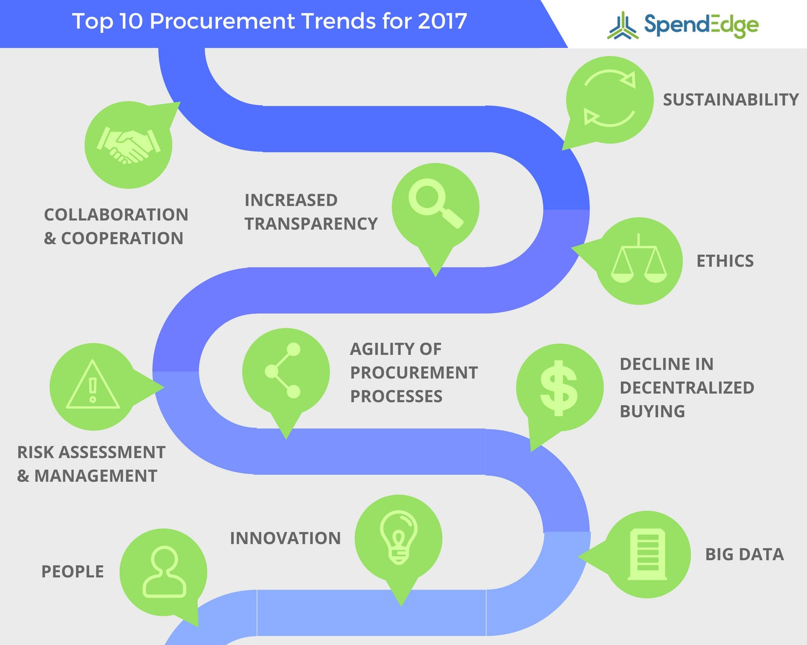
Procurement is quickly evolving in response to changes and advancements in technology, personnel and hiring requirements, consumer demands and concerns, and business practices. Here are our top ten procurement trends that are set to bring on transformation in the near future:
- Big data will become a bigger part of procurement and will help facilitate procurement decisions, form processes, and choose suitable procurement solutions. Additionally, big data and artificial intelligence will work together to revolutionize the speed and overall efficiency of the supply chain and procurement processes. The use of machine learning algorithms in conjunction with big data will result in time and money savings for companies
- Decentralized buying will continue to decline while more companies will adopt and establish procurement departments to improve their spending decisions and profits. More companies will begin to prioritize relationships with suppliers and contractors and embrace the procurement process as a whole more efficiently and enthusiastically
- Agility of procurement processes will increase as a result of technological advances and as a result of improved relationships between suppliers and businesses, and between procurement teams and other parts of businesses. Companies will also want to increase their speed to meet increasing consumer demand to remain competitive in their industries
- Increased transparency due to social media and the prevalence of social data will require companies to be more accountable for their practices and actions, and will also give them a greater channel of communication with established and potential customers. The companies can then modify their processes and make procurement decisions based on what will ensure customer retention, sales, and overall success
- Sustainability will become a bigger part of companies’ procurement solutions and strategies. Procurement management and functions will extend to creating sustainable and environmentally-friendly supply chains, partnerships, and agreements that are also economically viable. As more Millennials and young professionals become involved with procurement, the impact on both environmental and economic sustainability is expected to increase due to their openness to innovation and their different views on economics.
- Ethics will also be prioritized in response to widespread consumer concerns and demand for ethically sourced products. Companies will be expected to use ethical ingredients, materials, and methods of sourcing and delivery.
- Innovation will increase across the board, becoming the newest way that companies gain a competitive edge against one another. Companies will become more open to taking some risks and seizing unconventional business opportunities as a way to differentiate themselves and break out of repetitive industry traditions that do not bring them their desired levels of success. Innovation will also have to peacefully co-exist with established industry priorities like cost reduction
- Risk assessment and management will undergo changes to accommodate innovation, the evolving technological world, and volatile political and global events such as Brexit. Companies will implement risk management practices and strategies that encompass total risk exposure as well as other factors like threat management, risk transfer pricing, and relationship risk assessment
- Collaboration and cooperation between companies and their suppliers to improve or create procurement services and other services will be on the rise, shifting the focus to value, quality, and team efforts. Collaboration is a good way for companies to get the best value for their money, improve relationships with suppliers, and decrease costs over the long term
- The people involved in procurement will have a significant impact on the transformation of the industry in the near future. More Millennials are entering the workforce and are helping change the way that businesses and procurement strategies operate. Additionally, more companies are hiring staff based on their soft skills rather than degrees and past titles, and are also hiring from unconventional (for procurement purposes) backgrounds such as education
Procurement is changing rapidly to keep pace with the evolving world around it, and its future looks bright. These expected changes to procurement will increase job opportunities, efficiency and productivity, customer loyalty and trust, and businesses’ overall profits and success.

